TASK-1
TITLE: Using a temperature sensor to read and display temperature data on an LCD or serial monitor
OBJECTIVE: The objective of this project is to design and implement a temperature monitoring system using a temperature sensor and Arduino, and display the temperature readings on a Serial Monitor or LCD.
COMPONENETS: 1. Arduino UNO
2. LM35 Temperature Sensor
3.16×2 LCD Display (optional)
4. Breadboard
5. Jumper wires
6. USB Cable
SOFTWARE USED: Tinkercad
WORKING PRINCIPLE: The LM35 temperature sensor produces an output voltage that is directly proportional to the temperature in Celsius.
For every 1°C, LM35 gives 10 mV output
Arduino reads this analog voltage using its ADC (Analog-to-Digital Converter)
The voltage is converted into temperature using the formula:
Temperature (°C) = Voltage × 100
The calculated temperature is then displayed on the Serial Monitor or LCD.
CIRCUIT DIAGRAM:
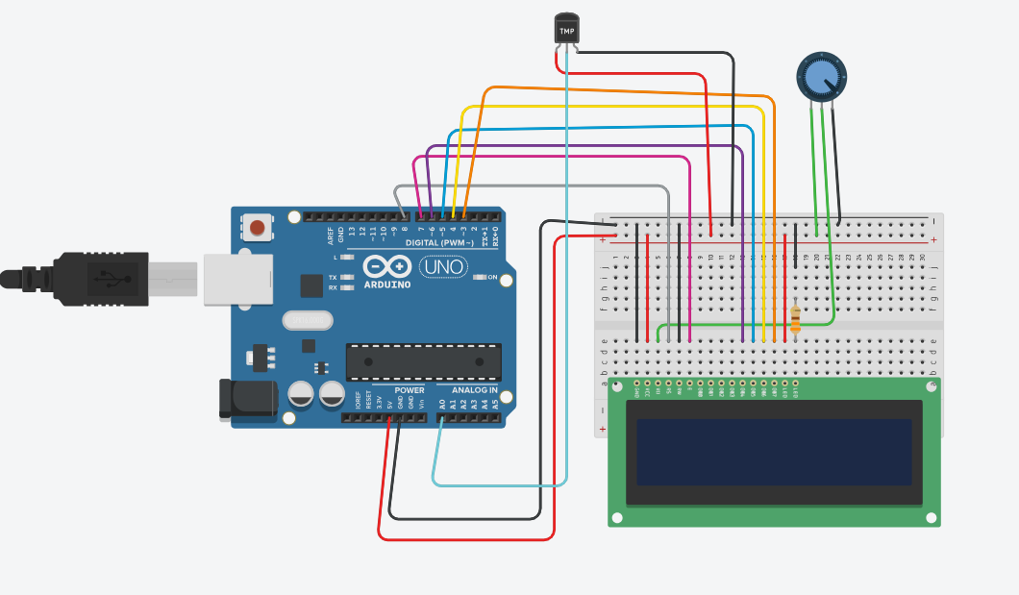
ARDUINO CODE:
#include "LiquidCrystal.h"

LiquidCrystal lcd(8,7,6,5,4,3);
int sensorPin = 0;

void setup()
{
Serial.begin(9600);
lcd.begin(16,2);
}

void loop()
{
int reading = analogRead(sensorPin);

// measure the 5v with a meter for an accurate value
// in particular if your Arduino is USB powered

float voltage = reading * 4.68;
voltage /= 1024.0;

// now print out the temperature

float temperatureC = (voltage - 0.5) * 100;
Serial.print(temperatureC);
Serial.println(" degrees C");

lcd.setCursor(0,0);
lcd.print("Temperature Value ");

lcd.setCursor(0,1);
lcd.print(" degrees C");

lcd.setCursor(11,1);
lcd.print(temperatureC);

delay(100);
}
OUTPUT:
The system continuously reads temperature and displays values like :
- 19.93
- 60.50
PRACTICAL OUTPUT:
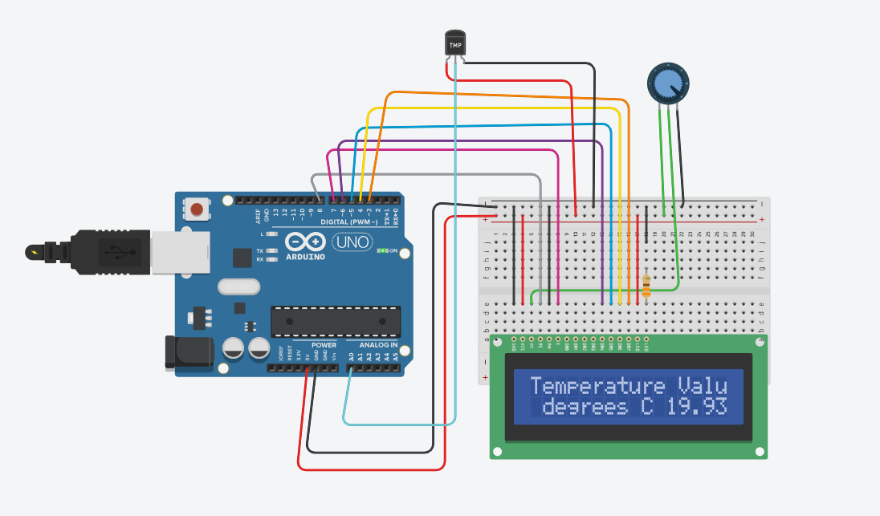
RESLUT:
The temperature monitoring system was successfully implemented using Arduino and LM35 sensor. The system accurately measures and displays temperature values on the Serial Monitor/LCD.

